**Eigen Vector & Eigen Value:**

Almost all vectors change direction, when they are multiplied by **A**. Certain exceptional vectors ***x*** are in the same direction as ***Ax***. Those are the “**eigenvectors**”. Multiply an eigenvector by **A**, and the vector ***Ax*** is a number **λ** times the original ***x***.

The basic equation is **Ax = λ x.** The number **λ** is an **eigenvalue of A.**

The eigenvalue **λ** tells whether the special vector ***x*** is stretched or shrunk or reversed or left unchanged—when it is multiplied by **A**. We may find **λ** = 2 or ½ or -1 or 1. The eigenvalue **λ** could be zero! Then *Ax = 0x* means that this eigenvector x is in the null-space.

If A is the identity matrix, every vector has Ax = x. All vectors are eigenvectors of I. All eigenvalues are **λ=1.**

Det(A-λI) = 0

From the basic equation,

Aν=cν; where c is eigen value, ν is eigen vector

Aν=cν; Aν-cν = 0;

ν(A-cI) = 0; since ν = Iν

Since ν≠0, A-cI=0

A-cI is a matrix, and must have linearly dependent columns, which are non-invertible

Determinant of A-cI is zero, det (A-cI) = 0, | A-cI| = 0

c – Eigen value of A if and only if det (A-cI) = 0

-------------------------------------------------------------------------------------------

**Let A = $\left[\begin{matrix}2 & 1 \\ 1 & 2\end{matrix}\right]$; Estimate Eigen value and Eigen vector of A.**

1. Let’s find the Eigen values of matrix A

Let λ be the eigen value of A

| A – λI | = 0

(2-λ)(2-λ) – 1 =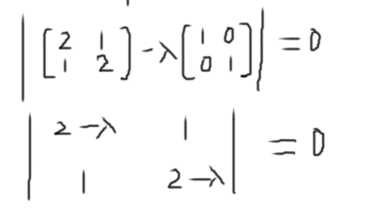 0

4-2λ-2λ+λ2 -1 = 0

λ2-4λ+3 = 0 🡪 Characteristic Polynomial

(λ - 3)( λ-1)=0

λ=3 or λ=1

The two eigen values of A are: λ=3 or λ=1

1. Let’s find the Eigen vectors of matrix A

We know,

Aν = λν

λν - Aν = 0

λIν - Aν = 0; ‘I’ being Identity matrix

(λI – A)ν = 0;

For any Eigen value (λ), the Eigen space (Eλ) = N(λI – A)

For λ = 3, E3 = N(3*I – A)

= N(-)

= N($\left[\begin{matrix}3 & 0 \\ 0 & 3\end{matrix}\right]$- $\left[\begin{matrix}2 & 1 \\ 1 & 2\end{matrix}\right]$)

= N($\left[\begin{matrix}1 & -1 \\ -1 & 1\end{matrix}\right])$

$\left[\begin{matrix}1 & -1 \\ -1 & 1\end{matrix}\right]$*V* = 0

By applying Row echelon form:

$\left[\begin{matrix}1 & -1 \\ 0 & 0\end{matrix}\right]\left[\begin{matrix}v1 \\ v2\end{matrix}\right]$ = $\left[\begin{matrix}0 \\ 0\end{matrix}\right]$

$v1$– $v2$ = 0

$v1$ = $v2$

Let $v1=t, then v2=t$

E3 = $\left[\begin{matrix}v1 \\ v2\end{matrix}\right]$ = $t\left[\begin{matrix}1 \\ 1\end{matrix}\right]$ = span $\left[\begin{matrix}1 \\ 1\end{matrix}\right]$

For λ = 1, E1 = N(1*I – A)

= N(-)

= N($\left[\begin{matrix}-1 & -1 \\ -1 & -1\end{matrix}\right])$

$\left[\begin{matrix}-1 & -1 \\ -1 & -1\end{matrix}\right]$*V* = 0

By applying Row echelon form:

=

- = 0

$v1=$ $- v2$

Let , then

E1 = = = span

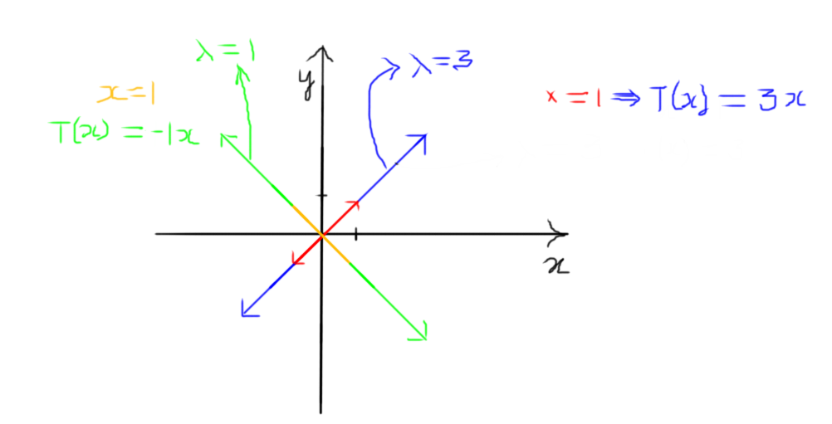

----------------------------------------------------------------------------------

**Let A = $\left[\begin{matrix}5 & 12 & -6 \\ -3 & -10 & 6 \\ -3 & -12 & 8\end{matrix}\right]$ Find Eigen vector and Eigen value**

Let c be the eigen value of A

If and only if, A *v* = c *v* for some non-zero vector

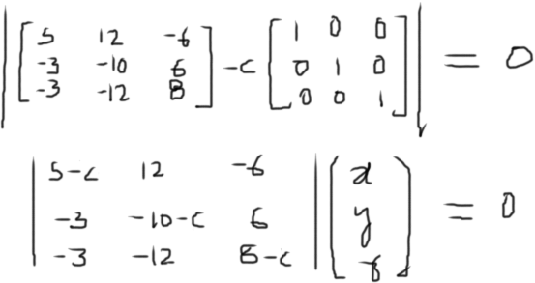

(5-c)x – 12y – 6z = 0 ----------(1)

-3x –(10+c)y +6z = 0 ---------(2)

-3x -12y + (8-c)z = 0 ---------(3)

On Row (3) 🡪 (3) - (2) 🡪 (10+c-12)y+ (2-c)z= 0

(-2+c)y –(-2+c)z = 0

(-2+c)(y-z) = 0

(c-2)(y-z) = 0

On solving the equations, we get:

-(λ -2)2 (λ +1) = 0

So (λ – 2)2 = 0 or λ +1 = 0

(λ -2) (λ -2) = 0 λ = -1

λ = 2 and λ = 2 λ = -1

So there are three values for λ: -1, +2, +2

We will get 2 vectors as solutions.

**Defective matrix:** A defective matrix is a square matrix that does not have a complete basis of eigenvectors, and is therefore not diagonalizable.

An n × n matrix is defective if and only if it does not have n linearly independent eigenvectors